**Project: Business Analysis and Modeling for an eBike Rental Startup**

Mobi-e-rides is a startup that focuses on providing eco-friendly transportation solutions by renting e-bikes to enthusiasts and tourists. The company plans to launch in a metropolitan area with high demand for sustainable transport options.

**Step 1: Identifying stakeholders for requirement gathering**

|  |  |  |
| --- | --- | --- |
| **Stakeholder** | **Example** | **Interest** |
| Customers | Bike renters (Enthusiasts and tourists looking for convenient transportation) | Easy rental process, availability of bikes, and pricing |
| Business owners | Founders of Mobi-e-rides | Profitability, customer  satisfaction, and market growth |
| Employees | Support agents, rental agents and maintenance staff | Efficient processes, job security, and training |
| Local government | Municipalities regulating  transportation | Give out license/ permits to the business to function in the are and ensure compliance with laws and policies |
| Investors | Angel investors, founders, businesses | Return on investment and  business viability |

**Step 2: Drafting interview questions for gathering requirements**

|  |  |  |
| --- | --- | --- |
| **Questions for customers (Enthusiasts and tourists)** | **Business owners (Founders of E** **Mobi-e-rides)** | **Employees (Rental agents and maintenance staff** |
| What do you think are the advantages of an e-bike over other methods of transportation? | What types of customers do you hope to serve with your e-bikes? | What is the regular process of renting out an e-bike? |
| What are the reasons you usually need to or will need to rent an e-bike? | How do you reach or plan to reach these customers? | What are the usual or regular complaints you have from customers? |
| What method or platform do you prefer to rent from? | What are the challenges you usually face with running the business? | How many hours do renters usually rent for? |
| Would you prefer to rent the bike on an hourly basis or daily basis? | How do you plan on meeting the needs for a higher demand? | How often do you have to do repairs or maintenance on bikes? |
| What is the maximum amount you are willing to pay to rent an e-bike per hour/ day? | What are the goals you aim to achieve in this launch? | What are the usual repairs and maintenance procedures you have to do? |
| What challenges or complaints have you had with your previous or current e-bike rental providers? |  | What are the challenges you usually face while renting out bikes to customers? |

**Step 3: Employing techniques for requirements prioritization**

|  |  |  |  |
| --- | --- | --- | --- |
| **Must have** | **Should have** | **Could have** | **Won’t have** |
| User friendly booking system | Mobile app for rentals | Customer loyalty program |  |
| Bike availability tracking | GPS tracking for individual bikes at launch | Integration with local tourist attractions |  |
| Payment processing functionality |  |  |  |

**Step 4: Traceability tools for requirements**

|  |  |  |  |  |
| --- | --- | --- | --- | --- |
| **Requirement ID** | **Description** | **Stakeholder** | **Status** | **Comments** |
| BR-001 | User Friendly booking system | Customers | In-progress |  |
| BR-002 | Bike availability tracking | Employees (Rental agents) | In-progress |  |
| BR-003 | Payment processing functionality | Customers | Completed |  |
| BR-004 | Mobile app for rentals | Customers | Planned |  |
| BR-005 | GPS tracking for individual bikes at launch | Employees (Maintenance staff) | Planned |  |
| BR-006 | Customer loyalty programs | Business owners | Planned |  |
| BR-007 | Integration with local tourist attractions | Business owners | Planned |  |
| BR-008 | Social media pages for the business | Business owners | Planned |  |

**Step 5: Facilitating workshops**

|  |
| --- |
| **Agenda**   * Opening remarks and appreciation * Introduction of workshop objectives * Introduction of key participants * Validation and prioritization of existing requirements * Discussion and brainstorming on new possible requirements * Further questions or suggestions * Wrap up |
| **Notes:**   * Most participants are on-board with the mobile app for rentals but customers seem to think downloading a new mobile app can be strenuous. Suggested web access * Bike availability idea loved by everyone * Customer loyalty program- (might not be necessary because most customers will be tourists and might not use the service long enough) * Suggested social media channels * Daily and hourly booking rates |

**Step 6: Observation techniques**

Example solution: Not applicable

You can consider analyzing existing rental services (if you have access to them) to understand their processes.

**Step 7: Designing surveys**

|  |
| --- |
| **Question 1:** On a scale of 1 to 5, how likely are you to download a new app for e-bike rental  **Question 2:** What features would you value most for renting an e-bike?  **Question 3:** When would you like to be charged for your rental? At the beginning or at the end?  **Question 4:** What would be the main reason you will consider for renting an e-bike?   * Convenience * Environmental impact * Cost savings * Other (please specify): __________   **Question 5:** How much are you willing to pay per hour for an e-bike rental?   * Under $10 * $10–$20 * $20–$30 * $30 or more |

**Step 8: Prototyping [Optional]**

|  |
| --- |
| **Key features**  Pick a bike  Select number of bikes  Select time  Estimate number of hours/days  Input valid payment details  Checkout  Booking confirmed |

**Step 9: Modeling business processes**

|  |  |
| --- | --- |
| **Entity** | **Attributes** |
| Customer | Customer_id  First_name  Last_name Customer_status  Payment_details  Customer_address  Phone_no  Email_address |
| Bikes | Bike_id  Bike_name  No_of _rentals  Bike_status |
| Payments | Payment_id  Rental_id  Customer_id  Bike_id  Payment_status  Date_of_payment |
| Maintenance logs | Maintenace_id  Bike_id  Employee_id  Maintenace_type  Maintenace_status |
| Employee | Employee_id  Employee_name  Employee_role |
| Rentals | Rental_id  Customer_id  Customer_name  Payment_id  Employee_id  Employee_name  Bike_id  Bike_name  Rental_time  Rental_duration  Rental_status |

**ERD diagram**: Created using Lucidchart

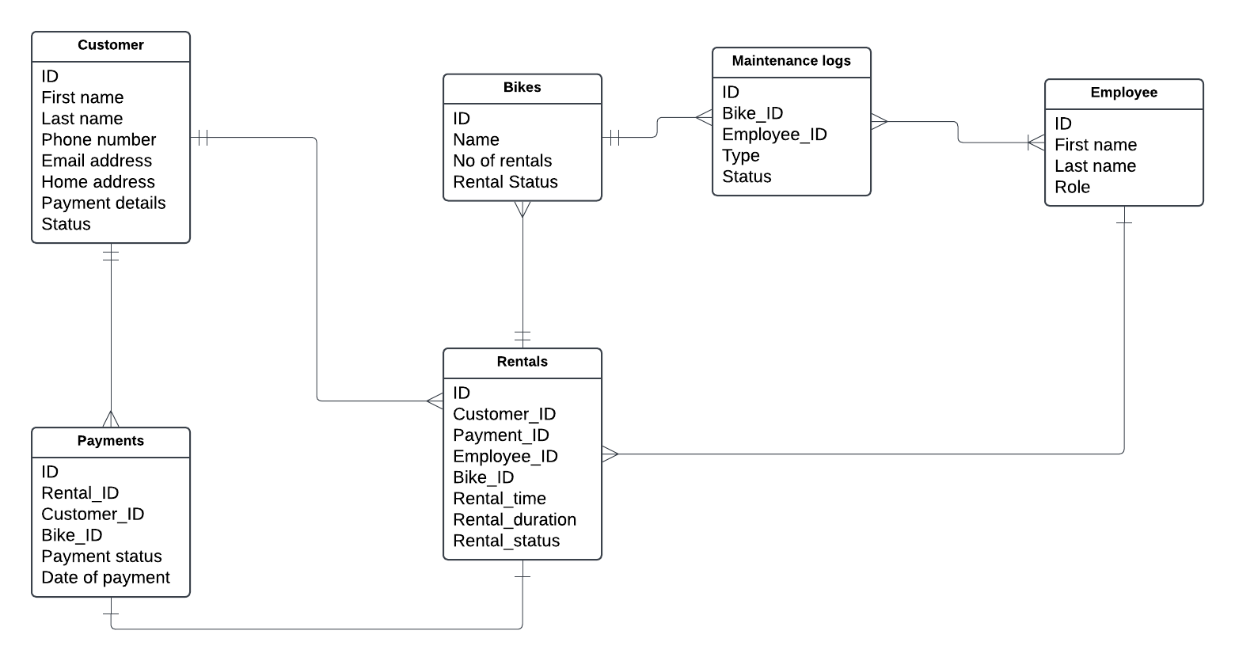

**Step 10: Use case diagram**

|  |
| --- |
| **Actors**   * **Customers** * **Maintenance agents** * **Rental agents** * **Payment processing system** |
| **Use cases**   * **Create a rental** * **Pay for a rental** * **Claim a rental** * **Return a rental** * **Cancel a rental** * **Process payment** * **Update maintenance status** * **Update bike status** * **Update rental status** |

**Use case diagram**: Created using Lucidchart

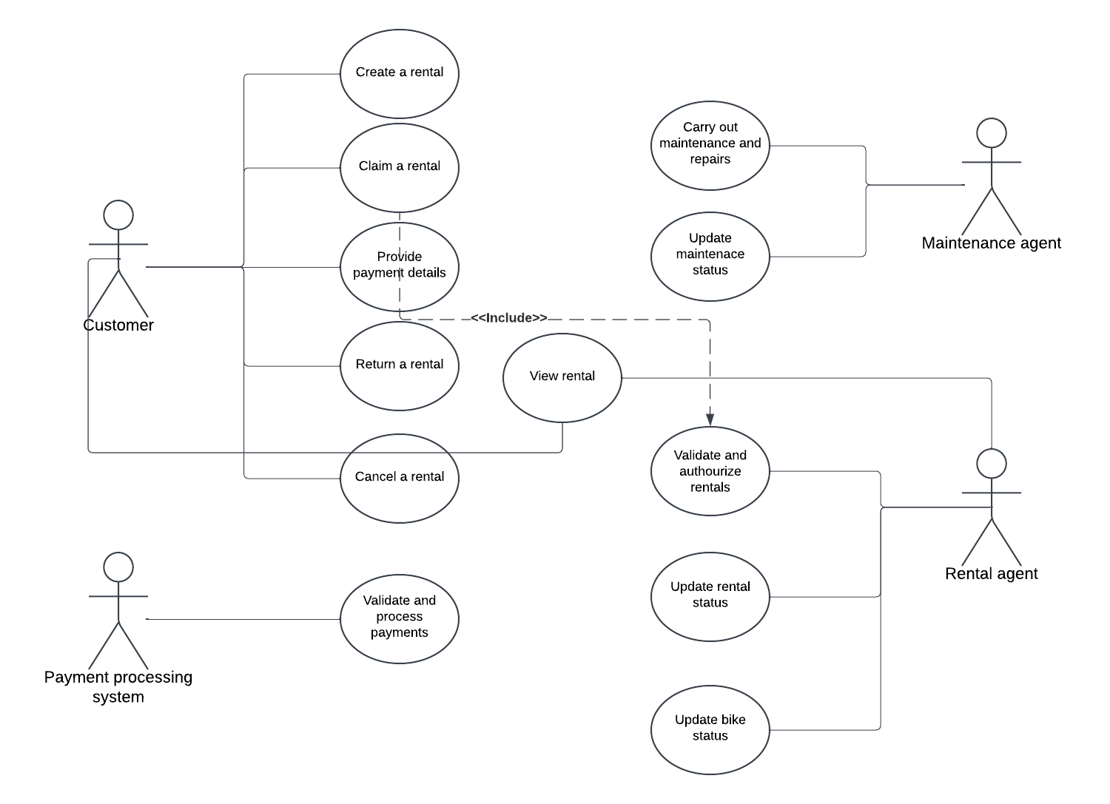

**Step 11: Mapping out business processes**

|  |
| --- |
| **Process steps**   * Start * Create a rental * Provide payment details * Validate payment details (Successful, Yes/No) * Confirm rental * Validate rental * Claim rental * Update bike and rental status * Return rental * Update bike and rental status * End |

**Flowchart**: To be created using a diagramming tool, such as Lucidchart.

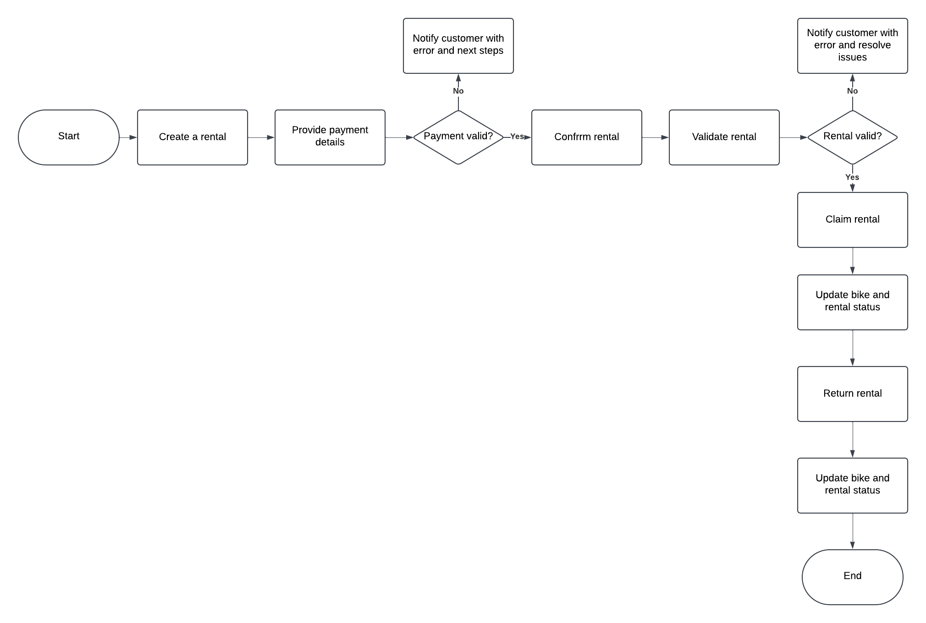

**Step 12: Systems analysis**

The systems analysis phase is crucial for evaluating the technical requirements, constraints, and potential solutions for the e-Bike rental system. This step involves understanding the current systems, identifying gaps, and proposing a robust solution that aligns with business goals and stakeholder needs.

**Objectives of systems analysis**

* Identify technical requirements for the e-Bike rental system
* Assess constraints that may impact system design and implementation
* Explore potential solutions that meet identified requirements
* Ensure the system is scalable, secure, and user-friendly

|  |
| --- |
| 1. **Requirements gathering**  * **Functional requirements:**  1. Users should be able to register using email or social media accounts 2. The system must allow users to update their profiles (for example, personal information, and payment methods) 3. Users need to log in securely with password protection and two-factor authentication (2FA) 4. Users should be able to initiate an e-bike rental by selecting the type of bike they want to rent 5. Users should be able to select the number of bikes they want to rent 6. Users should be able to select the time and duration of their rental 7. Users should be able to select a payment method for their rental 8. Users shall be able to create a new payment method 9. The payment method should be verified using a payment processing system 10. The system shall notify users if the payment method validation was successful, 11. The system shall notify users with error messages and next steps if the payment method is not successful 12. Once a rental is confirmed the system shall automatically schedule an e-bike for the customer 13. Rental agents should be able to update and change the status of e-bikes for real-time availability on the system 14. Once a rental has been confirmed, the system shall ensure that the e-bike assigned is not simultaneously booked by another user  * **Nonfunctional requirements:**  1. The registration process should be completed within five minutes 2. The system should handle up to 10,000 simultaneous user registrations without performance degradation |
| 1. **Stakeholder analysis**  * **Customers:** Expect a seamless registration experience with privacy protection * **Admin staff:** Need access to user data for management but want to ensure data security * **IT staff:** Require a manageable system that integrates smoothly with existing databases * **Maintenance staff:** Require a seamless system to schedule, maintain and update status of e-bikes and rentals |
| 1. **Current system evaluation**  * The current registration process which is manual, is both time-consuming and prone to errors. The new system must eliminate these issues by automating user registrations and rental management. |
| 1. **Technology assessment**  * **Constraints**   **Budget constraints:** Limitations on funding may restrict the choice of technologies and features implemented at launch  Technical expertise: The development team’s familiarity with specific technologies (e.g., cloud services, databases) could impact implementation speed and effectiveness  **Compliance and regulatory constraints:** Adherence to local regulations concerning data privacy (GDPR, CCPA) and safety requirements for e-bikes  Integration issues: The need to integrate with existing systems (e.g., payment gateways, third-party services) may introduce compatibility challenges   * **Potential solutions**   **Cloud-based identity management:** Consider implementing a service like Auth0 or Firebase Authentication for secure user registration and login. These platforms offer built-in features such as social logins and MFA.  **Payment processing solutions:** Use a reliable payment gateway like Stripe or PayPal that complies with PCI DSS standards. These services provide APIs for easy integration and support multiple payment methods.  **Database management:** Implement a relational database management system (RDBMS) such as PostgreSQL or MySQL to store user data, rental transactions, and inventory details securely. Choose NoSQL options like MongoDB if flexibility in schema design is needed for certain features.  **Real-time inventory tracking:** Utilize cloud-based inventory management software that can integrate with the rental platform. This allows for real-time updates on bike availability and maintenance status.  **User interface design:** Invest in user experience (UX) design to ensure the website and mobile app are intuitive. Tools like Figma or Adobe XD can be used for prototyping and user testing before full scale development. |
| 1. **Risk analysis**  * Potential risks include data breaches due to weak passwords or inadequate encryption * Operational risks involve users struggling with the new registration process, leading to abandoned accounts |
| 1. **Proposed solutions**  * Implement a cloud-based authentication service that provides robust security features * Use encryption methods (for example, bcrypt) for storing user passwords securely * Create user-friendly documentation and tutorials to help customers navigate the registration process effectively |